QUESTION 1

package com.selenium.test1.selenium1;

import org.openqa.selenium.By;

import org.openqa.selenium.WebDriver;

import org.openqa.selenium.chrome.ChromeDriver;

import org.openqa.selenium.chrome.ChromeOptions;

import org.testng.Assert;

import io.github.bonigarcia.wdm.WebDriverManager;

public class QUE1 {

public static void main( String[] args ) throws InterruptedException

{

WebDriverManager.chromedriver().setup();

ChromeOptions co=new ChromeOptions();

co.addArguments("--remote-allow-origins=*");

WebDriver driver=new ChromeDriver(co);

driver.get("https://www.saucedemo.com/");

driver.manage().window().maximize();

driver.findElement(By.name("user-name")).sendKeys("standard_user");

driver.findElement(By.name("password")).sendKeys("secret_sauce");

driver.findElement(By.id("login-button")).click();

driver.get("https://www.saucedemo.com/inventory-item.html?id=2");

driver.findElement(By.id("add-to-cart-sauce-labs-onesie")).click();

System.out.println("Added to cart");

driver.findElement(By.className("shopping_cart_link")).click();

System.out.println("Cart is visible");

driver.findElement(By.id("checkout")).click();

System.out.println("Checkout is visible");

driver.findElement(By.name("firstName")).sendKeys("AJAY");

driver.findElement(By.name("lastName")).sendKeys("VIJAYARAJ");

driver.findElement(By.name("postalCode")).sendKeys("629202");

driver.findElement(By.name("continue")).click();

System.out.println("Overview is visible");

String name=driver.findElement(By.xpath("//*[@id=\"item_2_title_link\"]/div")).getText();

System.out.println(name);

String price=driver.findElement(By.xpath("//*[@id=\"checkout_summary_container\"]/div/div[1]/div[3]/div[2]/div[2]/div")).getText();

System.out.println(price);

String t="Swag Labs";

String t1=driver.getTitle();

Assert.assertEquals(t,t1);

System.out.println("Title is verified");

String url="https://www.saucedemo.com/checkout-step-two.html";

String ActualUrl=driver.getCurrentUrl();

Assert.assertEquals(url,ActualUrl);

System.out.println("URL is verified");

}

}

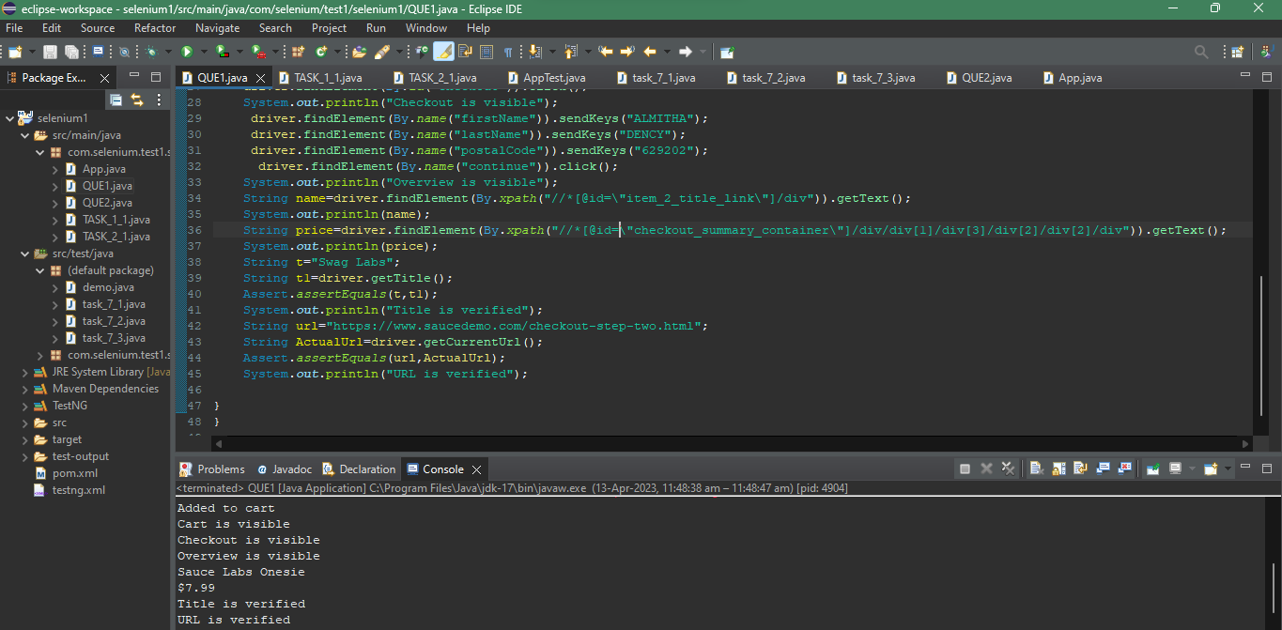

QUESTION 2

Task 2.1

package com.selenium.test1.selenium1;

import org.openqa.selenium.By;

import org.openqa.selenium.WebDriver;

import org.openqa.selenium.WebElement;

import org.openqa.selenium.chrome.ChromeDriver;

import org.openqa.selenium.chrome.ChromeOptions;

import org.openqa.selenium.support.ui.Select;

import io.github.bonigarcia.wdm.WebDriverManager;

public class QUE2_1 {

public static void main( String[] args ) throws InterruptedException

{

WebDriverManager.chromedriver().setup();

ChromeOptions co=new ChromeOptions();

co.addArguments("--remote-allow-origins=*");

WebDriver driver=new ChromeDriver(co);

driver.get("https://www.saucedemo.com/");

driver.manage().window().maximize();

driver.findElement(By.name("user-name")).sendKeys("standard_user");

driver.findElement(By.name("password")).sendKeys("secret_sauce");

driver.findElement(By.id("login-button")).click();

WebElement sort1=driver.findElement(By.className("product_sort_container"));

sort1.click();

System.out.println("A-Z is applicable");

Select select=new Select(sort1);

select.selectByIndex(1);

System.out.println("Z-A is applicable");

}

}

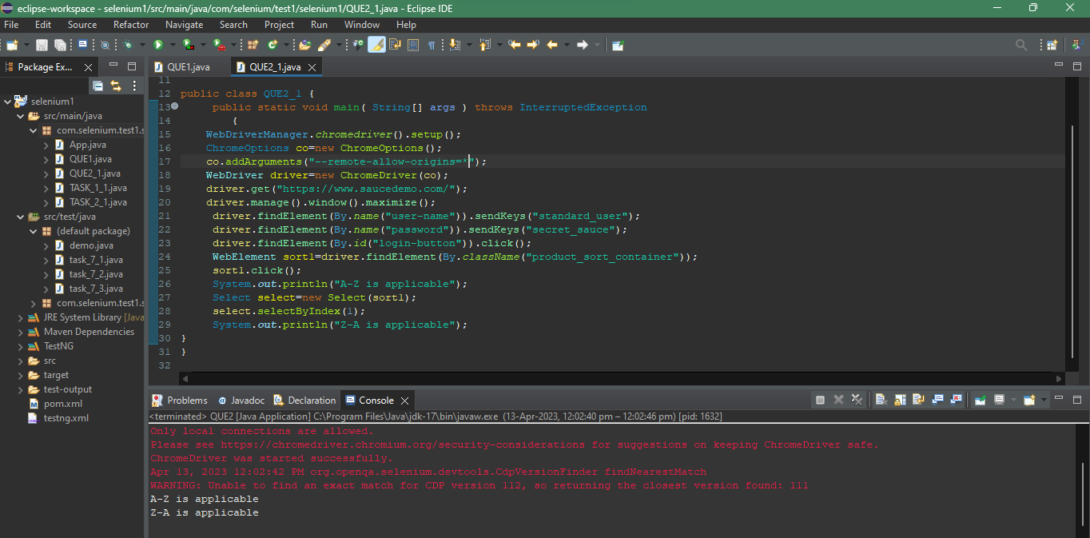

Task 2.2

package com.selenium.test1.selenium1;

import org.openqa.selenium.By;

import org.openqa.selenium.WebDriver;

import org.openqa.selenium.WebElement;

import org.openqa.selenium.chrome.ChromeDriver;

import org.openqa.selenium.chrome.ChromeOptions;

import org.openqa.selenium.support.ui.Select;

import io.github.bonigarcia.wdm.WebDriverManager;

public class QUE2_2 {

public static void main( String[] args ) throws InterruptedException

{

WebDriverManager.chromedriver().setup();

ChromeOptions co=new ChromeOptions();

co.addArguments("--remote-allow-origins=*");

WebDriver driver=new ChromeDriver(co);

driver.get("https://www.saucedemo.com/");

driver.manage().window().maximize();

driver.findElement(By.name("user-name")).sendKeys("standard_user");

driver.findElement(By.name("password")).sendKeys("secret_sauce");

driver.findElement(By.id("login-button")).click();

WebElement sort1=driver.findElement(By.className("product_sort_container"));

sort1.click();

Select select=new Select(sort1);

select.selectByIndex(0);

String fpo=driver.findElement(By.className("inventory_item_name")).getText();

System.out.println(fpo);

select.selectByIndex(1);

String fp1=driver.findElement(By.className("inventory_item_name")).getText();

System.out.println(fp1);

}

}

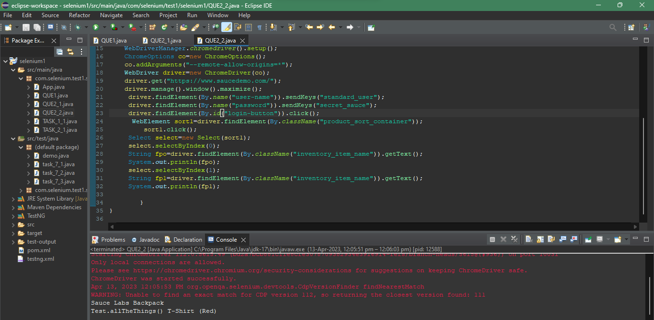

Task 2.3

package com.selenium.test1.selenium1;

import org.openqa.selenium.By;

import org.openqa.selenium.WebDriver;

import org.openqa.selenium.WebElement;

import org.openqa.selenium.chrome.ChromeDriver;

import org.openqa.selenium.chrome.ChromeOptions;

import org.openqa.selenium.support.ui.Select;

import io.github.bonigarcia.wdm.WebDriverManager;

public class QUE2_3 {

public static void main( String[] args ) throws InterruptedException

{

WebDriverManager.chromedriver().setup();

ChromeOptions co=new ChromeOptions();

co.addArguments("--remote-allow-origins=*");

WebDriver driver=new ChromeDriver(co);

driver.get("https://www.saucedemo.com/");

driver.manage().window().maximize();

driver.findElement(By.name("user-name")).sendKeys("standard_user");

driver.findElement(By.name("password")).sendKeys("secret_sauce");

driver.findElement(By.id("login-button")).click();

WebElement sort1=driver.findElement(By.className("product_sort_container"));

sort1.click();

Select select=new Select(sort1);

select.selectByIndex(2);

System.out.println("LOW-HIGH is applicable");

WebElement sort2=driver.findElement(By.className("product_sort_container"));

sort2.click();

Select select1=new Select(sort2);

select1.selectByIndex(3);

System.out.println("HIGH-LOW is applicable");

}

}

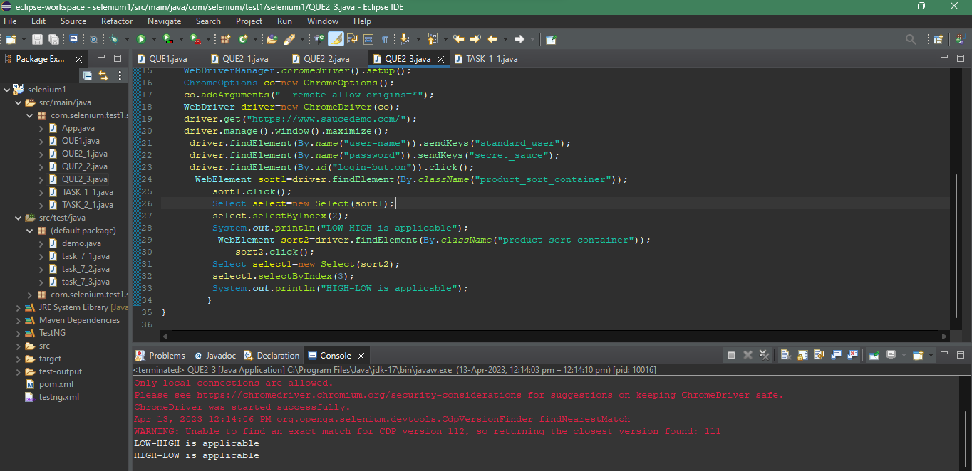

Task 2.4

package com.selenium.test1.selenium1;

import org.openqa.selenium.By;

import org.openqa.selenium.WebDriver;

import org.openqa.selenium.WebElement;

import org.openqa.selenium.chrome.ChromeDriver;

import org.openqa.selenium.chrome.ChromeOptions;

import org.openqa.selenium.support.ui.Select;

import io.github.bonigarcia.wdm.WebDriverManager;

public class QUE2_4 {

public static void main( String[] args ) throws InterruptedException

{

WebDriverManager.chromedriver().setup();

ChromeOptions co=new ChromeOptions();

co.addArguments("--remote-allow-origins=*");

WebDriver driver=new ChromeDriver(co);

driver.get("https://www.saucedemo.com/");

driver.manage().window().maximize();

driver.findElement(By.name("user-name")).sendKeys("standard_user");

driver.findElement(By.name("password")).sendKeys("secret_sauce");

driver.findElement(By.id("login-button")).click();

WebElement sort1=driver.findElement(By.className("product_sort_container"));

sort1.click();

Select select=new Select(sort1);

select.selectByIndex(2);

String d1=driver.findElement(By.className("inventory_item_name")).getText();

System.out.println(d1);

WebElement sort2=driver.findElement(By.className("product_sort_container"));

sort2.click();

Select select1=new Select(sort2);

select1.selectByIndex(3);

String d2=driver.findElement(By.className("inventory_item_name")).getText();

System.out.println(d2);

}

}

